Year 1 – Homework activities including regular reading
Spring 2
Weeks | w/b 24/02/25 | w/b 03/03/25 | w/b 10/03/25 | w/b 17/03/25 | w/b 24/03/25 | w/b 31/04/25
English | Watch this video of Stanley’s stick  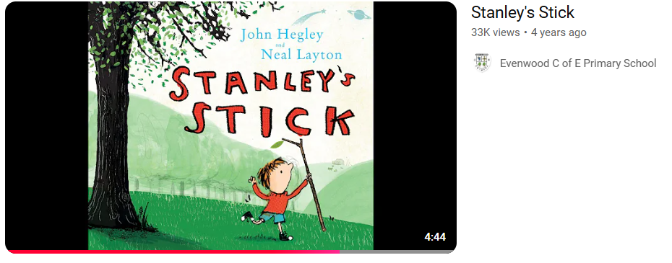  Stanley's Stick- YouTube  In the story Stanley’s stick can change into many amazing things.  Draw a picture of your special stick and write a few sentences about what cool things your magic stick can do! | Again, watch this video of ‘Stanley’s stick’  Stanley's Stick- YouTube  Now re-tell the story. Write it and add lots of detail to make it descriptive (using adjectives). | Write a book review of ‘.  Dinosaurs and All That Rubbish - YouTube  - What was it about?  - Did you like it? Why?  - What was your favourite part? | Write a list of instructions on how to look after the earth.  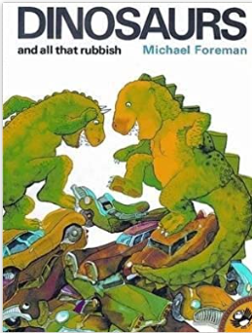 | Re-write your own version of Dinosaurs and All That Rubbish’. ‘  You can keep the story the same or you can change parts if you want. | Think about the story that we have been reading ‘ Dinosaurs and All That Rubbish’  Create a brainstorm- about some dreams and hopes you have for the future.  
Maths | Practice some subtracting with numbers up to 20.  For example, 20-8= 19-6=  18-5= 17-7=  Use a number line to help you.  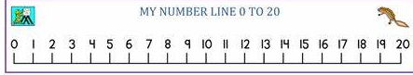 | Make a number line from 20-50.  Practice counting to 50 forwards, and backwards at home. | Make a number grid to 50 and colour in all the tens.  Can you notice a pattern? Write it in your book.  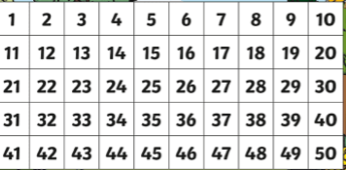 | Answer the following questions using the grid you have previously made.  a) 1 less than 17  b) 1 less than 50  c) 1 more than 2 tens 6 ones d) 1 more than 40 | Compare lengths and heights-using objects you can find at home or your furniture. Draw and compare both in your book.  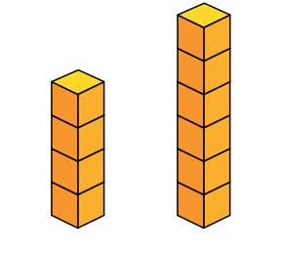  Which is taller and shorter? | Look for objects that light and heavy at home. Can you draw the objects and write which one was heavy and light under each object.  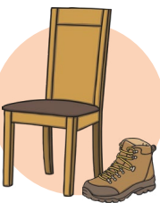
Wider  Curriculum | Make a poster to show how to stay healthy. Explain why it is important to stay healthy and share all your top tips!  (Food, sleep, exercise, relaxing, staying clean) | History Kings Queens and Castles  Make a fact file poster about King Charles III. Write everything you have learnt about him!  What is his role in our country? What are the names of the castles the Royal family live in? Draw pictures too! 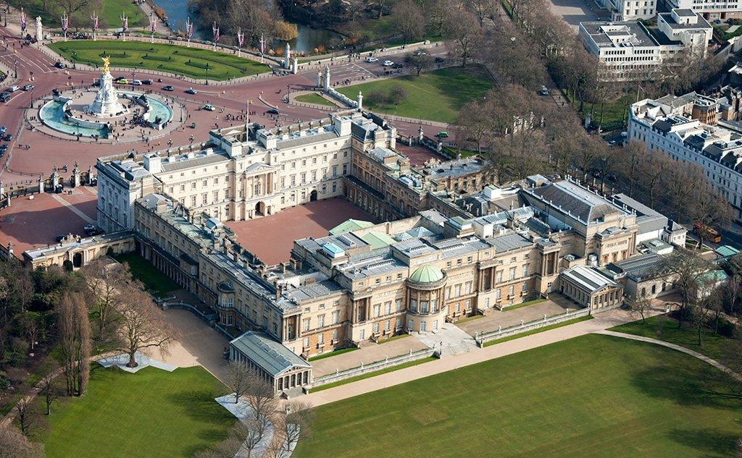 | In Science we have been learning about seasonal change. Fold a piece of paper into 4 sections, labelling them as ‘Spring’, ‘Summer’ ‘Autumn’ ‘Winter’. In each section, draw and label a picture that represents each season. | Since it is the festival of Ramadan, and we are learning about how different festivals are special to different people. Can you write a few sentences about what Ramadan is? Why is it important to Muslims?  | Can you draw a silhouette outline of your body (not to scale!) and then colour it in using interesting mixes of colours. | Make a poster to explain what you know about different celebrations are celebrated around the world. Choose one celebration or many celebrations to write about.
Spellings:These words are taken from the National Curriculum’s Year 1 spelling list – a list of words which children should be able to spell by the end of Year 1.
- shark  - ship  - park  - seaweed  - Coral reef | - have  - there  - like  - are  - he | - wood  - plastic  - glass  - metal  - water  - rock | - what  - when  - they  - one  - some | - were  - little  - most  - she  - come | - world  - smell  - clean  - dirty  - litter
Number:
Children in Year 1 are expected to count from 20-50.
Children should practice counting to 50 (can use their number lines to help them) and to also count in their 10’s.
Practise counting to 50. | Practise writing numbers to 50, as numerals and words (i.e 25 twenty-five). | Practise counting in their 10’s. | 15 + 5= 13 + 4=  8 + 12= 6 + 8 =  9 + 5 = 10 + 4 = | Get someone to count to 50, forwards and backwards with you.

