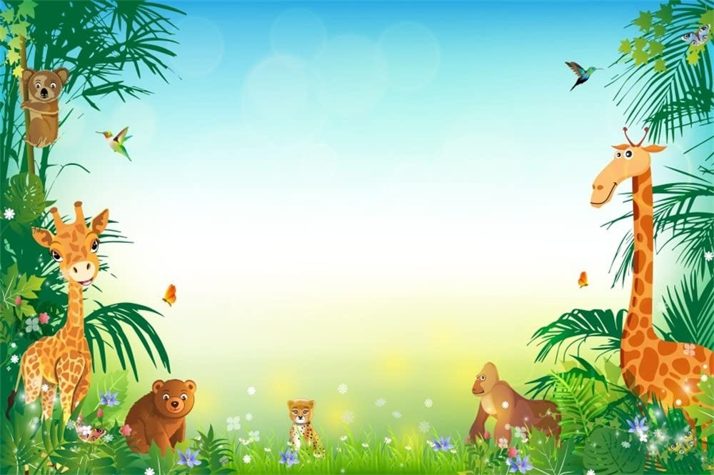

Personal, Social & Emotional Development

Children will:

*Learn that **exercise** keeps us healthy

*Understand that **moving and resting** are good for our bodies

*Know which **foods** are healthy and not healthy

*Know that **sleep** is important

*Understand the need to **wash** our hands

*Learn about **stranger danger**

Mathematical Development

Children will:

*Consolidate their understanding of the composition of numbers by looking at **numbers within numbers** so that *they can represent quantities using 5 and x more.*

* Use the language of **‘more than’, ‘less than’ and ‘equal to’** *to compare quantities.*

*Build on their understanding of **equal amounts**, and they will investigate equal groups in order to *explore doubling quantities to 10*

Animals **~**

**Reception**

Communication & Language/ Literacy Development

Children will:

*Use their **own ideas** to change the characters in a story so that they can make their own ‘lift the flap’ book

*Use their phonic knowledge so that they can **write** their story

*Retell stories about animals so that they use **story language** and understand and **learn new vocabulary**

*Continue to learn to **form letters** correctly and organise their writing so that they, and others, can read their writing

*Continue to develop an **understanding** of ‘What makes good reading’ during shared reading sessions so that they can handle books correctly

Understanding The World

Children will:

*Learn about what **animals look like** and the **noises** they make

*Learn about **animal habitats**

*Learn about **environmental changes** caused by deforestation and global warming

Physical Development

Children will:

* Use **small equipment** that require fine motor control like scissors and pencils

\***Follow instructions** during outdoor PE sessions

* Learn how to **travel with a ball** with increasing control

*Learn how to **stop a slow-moving ball**

*Learn how to **kick a ball**, aiming it into a net

Events

Indoor PE – Sunstone on Mondays and Starstone on Tuesdays.

**PE kits must be kept in school**

Outdoor PE – Starstone on Mondays and Sunstone on Thursdays.

**Sensible shoes to be worn.**

Parent workshops for Maths and Healthy Movers – dates to be confirmed.

Trip to the farm – dates to be confirmed.

Reception show – Thursday 3rd April at 3pm

Expressive Arts & Design

Children will:

\***Recreate** roles and experiences in the Vets

*Use their **imagination** when inventing own animals

*Learn about the **elements of music** using instruments

*Learn to **sing new songs** for the parent show

**How you can help at home**

* Talk about different animals. Investigate specific animals of choice and share this with us.
* Ask your child which sounds have been taught in Phonics. Play ‘I spy…’
* Read with your children daily and complete their reading records together (new reading pack).
* Complete weekly homework, including new Maths homework.
* Read books on Bug Club.
* Log onto Teams for updated information, photos and more…