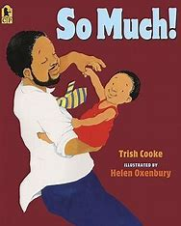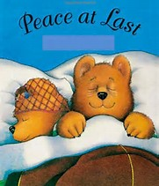

**Events**  Trip to Young V & A Museum – 11th July New Year one parent meeting – TBC Reception Graduation – TBC

Ourselves

**How you can help at Home**

* Talk to your child about moving into Year one in September.
* Read **EVERY** day and complete the reading diary twice a week.
* Complete the homework given every Friday and return to school every Wednesday.
* Ensure that your child has a bottle of water, hat and sun cream at school.
* Ensure that your child has a spare set of clothes so that they can take part in water play.
* Apply sun cream to your child before they come to school, please.

**Understanding the World**

Children will…

* Talk about what makes us human.
* Explore using their senses - taste, touch, hear, see and smell.
* Talk about parts of the body.
* Look at and talk about healthy and healthy foods.
* Compare themselves as babies and now.

So that they:

Know what makes us human.

Know the five senses.

Name parts of the body.

Understand the importance of a healthy diet.

Understand that humans grow and change.

**Expressive Arts & design**

Children will…

* Sing new songs about Eid and Ourselves.
* Recreate roles and experiences in our role play areas.
* Record/ represent themselves, their families and feelings through artwork.

So that they:

Perform songs using ‘What Makes a good performance’ criteria.

Speak about their thoughts and experiences.

Use their imagination.

**Physical Development**

Children will…

* Jump and roll in a range of ways from one space to another.
* Create sequences using different movements.
* Play group games involving control, co-ordination and turn taking.

So that they:

Jump and roll with control and balance.

Perform a sequence with confidence and control.

Take part in group games on Sports Day!

**Communication & Language & Literacy**

Children will…

* Talk about themselves
* Retell familiar stories
* Segment words to spell
* Learn to read and write common words

So that they:

Learn to use story language.

Can start to write down their own ideas.

Use their phonic knowledge when writing.

Apply word knowledge in reading and writing.

**Personal, Social & Emotional Development**

Children will…

* Talk about their own ideas in a large group.
* Take part in ‘Giant Club’.
* Look back at their time in Receptions.

So that they:

Share their ideas and opinions with others.

Express how they feel about moving to Year 1 including their worries and what they are looking forward to.

Share memories of their reception year.

**Mathematics**

Children will…

* Review previous learning of counting, number patterns, understanding and comparison.

So that they:

Consolidate previous learning.

Use their mathematical knowledge to solve a range of problems during practical activities.