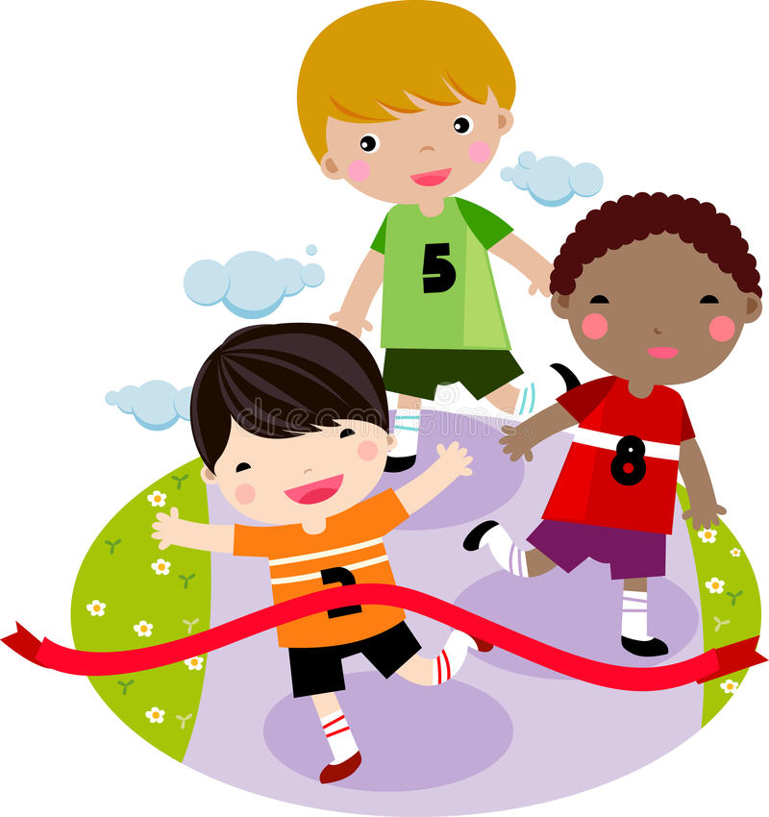

Religious Education

Children will:

* Learn about what Christians believe
* Retell stories that are important to Christians
* Compare how Christians pray

So that they…

Talk about simple ideas about Christian beliefs

Understand what Christians think about God

Geography

Children will:

* Look at photos of the local area
* Look at a range of maps
* Create maps of different locations
* Give directions using left, right, forwards, backwards

So that they…

Develop knowledge about their locality

Use locational and directional language

Devise a simple map involving a key

PSHE

Children will:

* Explore rights of a child
* Create a class charter
* Find out about class Dojos

So that they…

Understand our rights and responsibilities

Have a safe and happy learning environment

Understand what is expected of them in a learning environment

Maths

Children will:

* Work with numbers up to 10
* Compare numbers up to 10
* Count forwards and backwards to and from 10
* Say 1 more/1 less than a number to 10
* Make number bonds to 10
* Solve simple addition calculations using the part/part whole model

So that they...

Can order and compare numbers

Know and use number relationships

Understand maths in the real world

Begin to develop a written strategy for addition

Are confident and able to use numbers up to 10 within a range of mathematical situations.

English

Children will:

* Label pictures and create lists
* Learn What Makes A Good sentence
* Write a simple riddle
* Write a fact file based on the story ‘Astro Girl’
* Explore the story tale “Not Now Bernard”
* Use drama to support story development
* Orally rehearse and sequence sentences to create a story
* Take part in Daily Supported Reading
* Have daily phonics lessons

So that they…

Begin to write successful simple sentences

Write a complete sentence with a capital letter, finger spaces and punctuation including full stops.

Plan, draft, edit and publish a story with repetition

Write factual sentences

Write sentences to give clues about an animal

Apply their phonics knowledge when writing and reading

Develop fluency and reading comprehension

Computing

Children will:

* Learn about E-safety
* Explore using a chromebook
* Name different parts of a computer
* Log on to Chrome books

So that they…

Understand how to stay safe online

Can use chromebooks independently in the classroom

Physical Education

Children will:

* Have weekly indoor and outdoor PE lessons
* Explore a range of motion
* Navigate floor and apparatus spaces safely

So that they…

Learn to move in a controlled manner

Develop a short movement routine involving gymnastic movement and balance

Art

Children will:

* Explore different works of work
* Imitate colour and patterns of artists
* Recognise and continue patterns
* Take rubbings to create textured art

So that they…

Develop a wide range of art and design techniques in using colour, pattern, line, shape and texture

Science

Children will:

* Explore everyday materials
* Name materials
* Use their senses to feel materials
* Explore how some materials can be changed

So that they…

Identify the materials around them and talk about their suitability for particular uses

Describe the properties of everyday materials using scientific vocabulary

**Goals and Aspirations**

How You Can Help

* Support your child with their weekly homework (accessible on the Harbinger website)
* Encourage good hygiene and hand washing habits.
* Read every day with your child using BugClub or books that are sent home.