Talk Tuesday

Autumn 1st half term

Date | Tuesdays  KS2/KS1 Story Assembly  (Jubeda) or  Oracy Assemblies (Fiona)  or  oracy-focused time in class | Oracy Skill Introduced and Encouraged  Discussion Guidelines should be referred to in all oracy discussions  Sentence stems to be displayed  Assessment of skills must be recorded in some way by teachers and/or oracy ambassadors (see assessment proforma) | Talk Groupings Introduced and Encouraged  Opportunities for Nest should be given in all oracy discussions  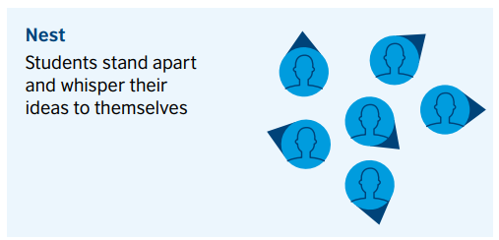 | Key Questions
w/b Sept 5th | KS1: Story Assembly  LKS2: In Class  UKS2: Oracy Assembly | KS1:  Physical: Speak clearly and confidently in a small group of known peers.  Linguistic: Begin to use sentence stems with some prompting.  LKS2:  Physical: Vary tone of voice.  Social & Emotional: Notice when someone has not contributed and invite them to speak.  UKS2:  Physical: Use gestures effectively to engage and persuade the audience. | 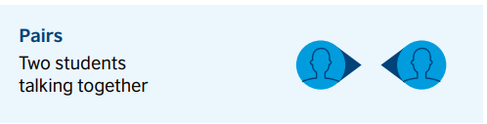 | Q: What is ‘Learning’?  What is ‘Togetherness’?  What is ‘Well-being?
w/b Sept 11th | KS1: Oracy Assembly  LKS2: Story Assembly  UKS2: In Class | KS1:  Physical: Using non-verbal signals confidently to indicate the contribution they wish to make. Agree, disagree, or build.  Linguistic: Choose the most appropriate stem independently.  LKS2:  Cognitive: Confidently summarise the contribution of one participant in a logical order.  UKS2:  Physical: To use posture, gestures, and tone of voice effectively to persuade the audience.  Cognitive: Be able to reply to questions from the audience. | 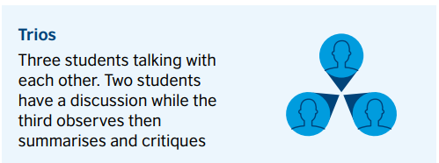 | Q: Is it ok for one person to make all the rules for everybody?
w/b Sept 18th | KS1: In Class  LKS2: Oracy Assembly  UKS2: Story Assembly | KS1:  Physical: Speak clearly and confidently in a small group of known peers.  Linguistic: Begin to use sentence stems with some prompting.  LKS2:  Physical: Vary tone of voice.  Social & Emotional: Notice when someone has not contributed and invite them to speak.  UKS2:  Physical: Use gestures effectively to engage and persuade the audience. | 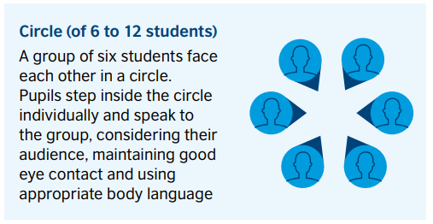 | Q: Should some people do more than others to take care of the Earth?
w/b Sept 25th | KS1: Story Assembly  LKS2: In Class  UKS2: Oracy Assembly | KS1:  Physical: Using non-verbal signals confidently to indicate the contribution they wish to make. Agree, disagree, or build.  Linguistic: Choose the most appropriate stem independently.  LKS2:  Cognitive: Confidently summarise the contribution of one participant in a logical order.  UKS2:  Physical: To use posture, gestures, and tone of voice effectively to persuade the audience.  Cognitive: Be able to reply to questions from the audience. | 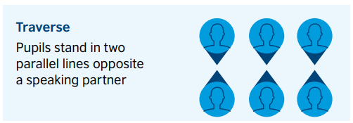 | Q: Is it helpful to learn other languages?
w/b Oct 2nd | KS1: Oracy Assembly  LKS2: Story Assembly  UKS2: In Class | KS1:  Physical: Speak clearly and confidently in a small group of known peers.  Linguistic: Begin to use sentence stems with some prompting.  LKS2:  Physical: Vary tone of voice.  Social & Emotional: Notice when someone has not contributed and invite them to speak.  UKS2:  Physical: Use gestures effectively to engage and persuade the audience. | 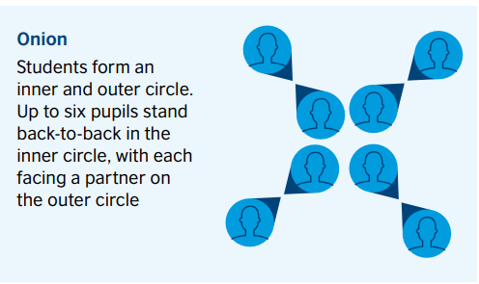 | Q: Are humans more important than animals?
W/b Oct 9th | KS1: In Class  LKS2: Oracy Assembly  UKS2: Story Assembly | KS1:  Physical: Using non-verbal signals confidently to indicate the contribution they wish to make. Agree, disagree, or build.  Linguistic: Choose the most appropriate stem independently.  LKS2:  Cognitive: Confidently summarise the contribution of one participant in a logical order.  UKS2:  Physical: To use posture, gestures, and tone of voice effectively to persuade the audience.  Cognitive: Be able to reply to questions from the audience. | 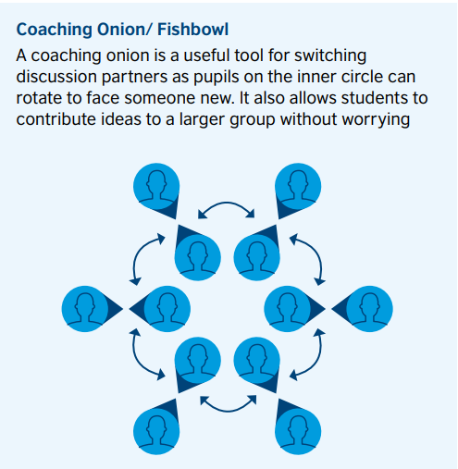 | Q: Which is more important:  Caring for yourself or caring for others?
W/b Oct 16th | KS1: Story Assembly  LKS2: In Class  UKS2: Oracy Assembly | KS1:  Physical: Speak clearly and confidently in a small group of known peers.  Linguistic: Begin to use sentence stems with some prompting.  LKS2:  Physical: Vary tone of voice.  Social & Emotional: Notice when someone has not contributed and invite them to speak.  UKS2:  Physical: Use gestures effectively to engage and persuade the audience. |  | Q: How do you show respect to someone who has a different religion to you/no religion?

Autumn 2nd half term
Date | Tuesdays  KS2/KS1 Story Assembly  (Jubeda) or  Oracy Assemblies (Fiona)  or  oracy-focused time in class | Oracy Skill  Discussion Guidelines should be referred to in all oracy discussions  Sentence stems to be displayed  Assessment of skills must be recorded in some way by teachers and/or oracy ambassadors (see assessment proforma) | Talk Groupings Introduced and Encouraged  Opportunities for Nest should be given in all oracy discussions | Key Questions
w/b Oct 30th | KS1: Oracy Assembly  LKS2: Story Assembly  UKS2: In Class | KS1:  Physical: Use non-verbal signals to indicate agreement or disagreement.  Cognitive: Include ‘because’ in their contribution to justify ideas.  LKS2:  Cognitive: Take on the challenger role in a small discussion.  Social & Emotional: Be able to confidently change their mind.  UKS2:  Linguistic: Use evaluative stems to support the discussion of successes and next steps. |  | Q: If someone hurts you, should you hurt them back?
w/b Nov 6th | KS1: In Class  LKS2: Oracy Assembly  UKS2: Story Assembly | KS1:  Cognitive: Justify their agree/disagree choice with relevant explanations.  Linguistic: Use technical, subject-specific vocabulary when explaining opinions.  LKS2:  Physical: Pause at appropriate points to allow for an audience’s reaction.  UKS2:  Linguistic: Use humour appropriately and effectively to engage an audience. |  | Q: What is peace?  What is freedom?
w/b Nov 13th | KS1: Story Assembly  LKS2: In Class  UKS2: Oracy Assembly | KS1:  Physical: Use non-verbal signals to indicate agreement or disagreement.  Cognitive: Include ‘because’ in their contribution to justify ideas.  LKS2:  Cognitive: Take on the challenger role in a small discussion.  Social & Emotional: Be able to confidently change their mind.  UKS2:  Linguistic: Use evaluative stems to support the discussion of successes and next steps. |  | Q: Do unkind words or unkind actions hurt more?
w/b Nov 20th | KS1: Oracy Assembly  LKS2: Story Assembly  UKS2: In Class | KS1:  Cognitive: Justify their agree/disagree choice with relevant explanations.  Linguistic: Use technical, subject-specific vocabulary when explaining opinions.  LKS2:  Physical: Pause at appropriate points to allow for an audience’s reaction.  UKS2:  Linguistic: Use humour appropriately and effectively to engage an audience. |  | Q: What makes me, me?
w/b Nov 27th | KS1: In Class  LKS2: Oracy Assembly  UKS2: Story Assembly | KS1:  Physical: Use non-verbal signals to indicate agreement or disagreement.  Cognitive: Include ‘because’ in their contribution to justify ideas.  LKS2:  Cognitive: Take on the challenger role in a small discussion.  Social & Emotional: Be able to confidently change their mind.  UKS2:  Linguistic: Use evaluative stems to support the discussion of successes and next steps. |  | Q: If you do something wrong but nobody saw you, is it still wrong?
W/b Dec 4th | KS1: Story Assembly  LKS2: In Class  UKS2: Oracy Assembly | KS1:  Cognitive: Justify their agree/disagree choice with relevant explanations.  Linguistic: Use technical, subject-specific vocabulary when explaining opinions.  LKS2:  Physical: Pause at appropriate points to allow for an audience’s reaction.  UKS2:  Linguistic: Use humour appropriately and effectively to engage an audience. |  | Q: Is it better to give or to receive?
W/b Dec 11th | KS1: Oracy Assembly  LKS2: Story Assembly  UKS2: In Class | KS1:  Physical: Use non-verbal signals to indicate agreement or disagreement.  Cognitive: Include ‘because’ in their contribution to justify ideas.  LKS2:  Cognitive: Take on the challenger role in a small discussion.  Social & Emotional: Be able to confidently change their mind.  UKS2:  Linguistic: Use evaluative stems to support the discussion of successes and next steps. |  | Q: Why do some people have more than others?
w/b 18th Dec | KS1: In Class  LKS2: Oracy Assembly  UKS2: Story Assembly | KS1:  Cognitive: Justify their agree/disagree choice with relevant explanations.  Linguistic: Use technical, subject-specific vocabulary when explaining opinions.  LKS2:  Physical: Pause at appropriate points to allow for an audience’s reaction.  UKS2:  Linguistic: Use humour appropriately and effectively to engage an audience. |  | Q: What have you most enjoyed this year so far?

Talk Tuesday
Spring 1st half term

Date | Tuesdays  KS2/KS1 Story Assembly  (Jubeda) or  Oracy Assemblies (Fiona)  or  oracy-focused time in class | Oracy Skill  Discussion Guidelines should be referred to in all oracy discussions  Sentence stems to be displayed  Assessment of skills must be recorded in some way by teachers and/or oracy ambassadors (see assessment proforma) | Talk Groupings Introduced and Encouraged  Opportunities for Nest should be given in all oracy discussions | Key Questions
w/b Jan 8th | KS1: Story Assembly  LKS2: In Class  UKS2: Oracy Assembly | KS1:  Physical: Speak clearly when presenting learning to the class.  Linguistic: Use sentence stems independently even if not always appropriately.  LKS2:  Linguistic: Use awareness of audience to support choice of formal/informal language.  Cognitive: Explain the purpose of their talk.  UKS2:  Cognitive: Use effective exploratory and evaluative language to clarify thinking during a discussion. |  | Q: Is it more important to be liked or respected?
w/b Jan 15th | KS1: Oracy Assembly  LKS2: Story Assembly  UKS2: In Class | KS1:  Physical: Begin to understand the importance of posture when speaking.  Linguistic: Use taught vocabulary independently, even if not always accurately.  LKS2:  Cognitive: Take on the summariser role in a discussion.  Linguistic: Show awareness of taught collocations and recognise when something ‘just doesn’t sound right.’  UKS2:  Cognitive: Use wider world knowledge to support views when participating in debates. |  | Footballer assembly tbc
w/b Jan 22nd | KS1: In Class  LKS2: Oracy Assembly  UKS2: Story Assembly | KS1:  Physical: Speak clearly when presenting learning to the class.  Linguistic: Use sentence stems independently even if not always appropriately.  LKS2:  Linguistic: Use awareness of audience to support choice of formal/informal language.  Cognitive: Explain the purpose of their talk.  UKS2:  Cognitive: Use effective exploratory and evaluative language to clarify thinking during a discussion. |  | Q: How do we know the difference between right and wrong?
w/b Jan 29th | KS1: Story Assembly  LKS2: In Class  UKS2: Oracy Assembly | KS1:  Physical: Begin to understand the importance of posture when speaking.  Linguistic: Use taught vocabulary independently, even if not always accurately.  LKS2:  Cognitive: Take on the summariser role in a discussion.  Linguistic: Show awareness of taught collocations and recognise when something ‘just doesn’t sound right.’  UKS2:  Cognitive: Use wider world knowledge to support views when participating in debates. |  | Q: Are our own feelings more important than others?
W/b Feb 5th | KS1: Oracy Assembly  LKS2: Story Assembly  UKS2: In Class | KS1:  Physical: Speak clearly when presenting learning to the class.  Linguistic: Use sentence stems independently even if not always appropriately.  LKS2:  Linguistic: Use awareness of audience to support choice of formal/informal language.  Cognitive: Explain the purpose of their talk.  UKS2:  Cognitive: Use effective exploratory and evaluative language to clarify thinking during a discussion. |  | Q: Should we show respect to everyone? (Online? Offline?)

Talk Tuesday
Spring 2nd half term

Date | Tuesdays  KS2/KS1 Story Assembly  (Jubeda) or  Oracy Assemblies (Fiona)  or  oracy-focused time in class | Oracy Skill  Discussion Guidelines should be referred to in all oracy discussions  Sentence stems to be displayed  Assessment of skills must be recorded in some way by teachers and/or oracy ambassadors (see assessment proforma) | Talk Groupings Introduced and Encouraged  Opportunities for Nest should be given in all oracy discussions | Key Questions
w/b Feb 19th | KS1: In Class  LKS2: Oracy Assembly  UKS2: Story Assembly | KS1:  Cognitive: Retell a story to a small group. Recognising when events are out of sequence and self-correcting.  Social & Emotional: Be able to independently take turns and ensure all members contribute.  LKS2:  Cognitive: Take part in a consensus circle and reach a shared conclusion. Deliver a short presentation (with notes) to an unfamiliar audience.  UKS2:  Cognitive: Present learning to parents in pupil-led parent meetings.  Linguistic: Use evaluative stems to support the discussion of successes and next steps. |  | Q: How do you demonstrate our school values of togetherness, well-being and learning?
w/b Feb 26th | KS1: Story Assembly  LKS2: In Class  UKS2: Oracy Assembly | KS1:  Physical: Moderate tone and volume to match the audience.  Cognitive: Retell an event calmly in logical order e.g. on the playground.  LKS2:  Physical: Project voice to the back of the hall and maintain that without shouting. E.g. during the play performance.  UKS2:  Cognitive: Choose appropriately formal language when participating in debates and formal discussions. Linguistic: Structure a persuasive speech effectively using taught language techniques. |  | Q: Can we be anything we want to be?
w/b Mar 4th | KS1: Oracy Assembly  LKS2: Story Assembly  UKS2: In Class | KS1:  Cognitive: Retell a story to a small group. Recognising when events are out of sequence and self-correcting.  Social & Emotional: Be able to independently take turns and ensure all members contribute.  LKS2:  Cognitive: Take part in a consensus circle and reach a shared conclusion. Deliver a short presentation (with notes) to an unfamiliar audience.  UKS2:  Cognitive: Present learning to parents in pupil-led parent meetings.  Linguistic: Use evaluative stems to support the discussion of successes and next steps. |  | Q: What is your favourite book?  Why are stories so important?
w/b Mar 11th | KS1: In Class  LKS2: Oracy Assembly  UKS2: Story Assembly | KS1:  Physical: Moderate tone and volume to match the audience.  Cognitive: Retell an event calmly in logical order e.g. on the playground.  LKS2:  Physical: Project voice to the back of the hall and maintain that without shouting. E.g. during the play performance.  UKS2:  Cognitive: Choose appropriately formal language when participating in debates and formal discussions. Linguistic: Structure a persuasive speech effectively using taught language techniques. |  | Q: What invention would you like to see in the future?
w/b Mar 18th | KS1: Story Assembly  LKS2: In Class  UKS2: Oracy Assembly | KS1:  Cognitive: Retell a story to a small group. Recognising when events are out of sequence and self-correcting.  Social & Emotional: Be able to independently take turns and ensure all members contribute.  LKS2:  Cognitive: Take part in a consensus circle and reach a shared conclusion. Deliver a short presentation (with notes) to an unfamiliar audience.  UKS2:  Cognitive: Present learning to parents in pupil-led parent meetings.  Linguistic: Use evaluative stems to support the discussion of successes and next steps. |  | Q: How can we save water in our world?
W/b Mar 25th | KS1: Oracy Assembly  LKS2: Story Assembly  UKS2: In Class | KS1:  Physical: Moderate tone and volume to match the audience.  Cognitive: Retell an event calmly in logical order e.g. on the playground.  LKS2:  Physical: Project voice to the back of the hall and maintain that without shouting. E.g. during the play performance.  UKS2:  Cognitive: Choose appropriately formal language when participating in debates and formal discussions. Linguistic: Structure a persuasive speech effectively using taught language techniques. |  | Q: How do you show respect to others in our community?

Talk Tuesday
Summer 1st half term

Date | Tuesdays  KS2/KS1 Story Assembly  (Jubeda) or  Oracy Assemblies (Fiona)  or  oracy-focused time in class | Oracy Skill  Discussion Guidelines should be referred to in all oracy discussions  Sentence stems to be displayed  Assessment of skills must be recorded in some way by teachers and/or oracy ambassadors (see assessment proforma) | Talk Groupings Introduced and Encouraged  Opportunities for Nest should be given in all oracy discussions | Key Questions
w/b Apr 15th | KS1: In Class  LKS2: Oracy Assembly  UKS2: Story Assembly | KS1:  Physical: Speak clearly and confidently when explaining.  Linguistic: Recognise when the wrong stem has been used and choose a more appropriate one.  LKS2:  Cognitive: Adapt explanation to suit audience reaction.  Social & Emotional: Be able to explain why they have changed their mind.  UKS2:  Cognitive: Independently discuss a question in a small group, maintaining focus on the question and roles. |  | Q: How do you look after the Earth?
w/b Apr 22nd | KS1: Story Assembly  LKS2: In Class  UKS2: Oracy Assembly | KS1:  Physical: Maintain suitable posture throughout a spoken contribution.  Cognitive: With support, identify a suitable question in response to a stimulus.  Social & Emotional: Be able to change their mind in response to another person’s argument.  LKS2:  Cognitive: Cite evidence from the linked wider experiences when participating in discussions.  UKS2:  Physical: To use posture, gestures, and tone of voice effectively to persuade the audience.  Cognitive: Be able to reply to questions from the audience. |  | Q: What is courage?
w/b Apr 29th | KS1: Oracy Assembly  LKS2: Story Assembly  UKS2: In Class | KS1:  Physical: Speak clearly and confidently when explaining.  Linguistic: Recognise when the wrong stem has been used and choose a more appropriate one.  LKS2:  Cognitive: Adapt explanation to suit audience reaction.  Social & Emotional: Be able to explain why they have changed their mind.  UKS2:  Cognitive: Independently discuss a question in a small group, maintaining focus on the question and roles. |  | Q: What would happen if we didn’t communicate how we feel?
w/b May 6th | KS1: In Class  LKS2: Oracy Assembly  UKS2: Story Assembly | KS1:  Physical: Maintain suitable posture throughout a spoken contribution.  Cognitive: With support, identify a suitable question in response to a stimulus.  Social & Emotional: Be able to change their mind in response to another person’s argument.  LKS2:  Cognitive: Cite evidence from the linked wider experiences when participating in discussions.  UKS2:  Physical: To use posture, gestures, and tone of voice effectively to persuade the audience.  Cognitive: Be able to reply to questions from the audience. |  | Q: What is mutual respect?
w/b May 13th | KS1: Story Assembly  LKS2: In Class  UKS2: Oracy Assembly | KS1:  Physical: Speak clearly and confidently when explaining.  Linguistic: Recognise when the wrong stem has been used and choose a more appropriate one.  LKS2:  Cognitive: Adapt explanation to suit audience reaction.  Social & Emotional: Be able to explain why they have changed their mind.  UKS2:  Cognitive: Independently discuss a question in a small group, maintaining focus on the question and roles. |  | Q: What helps you learn?
W/b May 20th | KS1: Oracy Assembly  LKS2: Story Assembly  UKS2: In Class | KS1:  Physical: Maintain suitable posture throughout a spoken contribution.  Cognitive: With support, identify a suitable question in response to a stimulus.  Social & Emotional: Be able to change their mind in response to another person’s argument.  LKS2:  Cognitive: Cite evidence from the linked wider experiences when participating in discussions.  UKS2:  Physical: To use posture, gestures, and tone of voice effectively to persuade the audience.  Cognitive: Be able to reply to questions from the audience. |  | Q: What are you proud of?

Talk Tuesday
Summer 2nd half term

Date | Tuesdays  KS2/KS1 Story Assembly  (Jubeda)  or  Oracy Assemblies (Fiona)  or  oracy-focused time in class | Oracy Skill  Discussion Guidelines should be referred to in all oracy discussions  Sentence stems to be displayed  Assessment of skills must be recorded in some way by teachers and/or oracy ambassadors (see assessment proforma) | Talk Groupings Introduced and Encouraged  Opportunities for Nest should be given in all oracy discussions | Key Questions
w/b Jun 3rd |  | KS1:  Physical: Speak clearly and confidently.  Social & Emotional: Maintain eye contact.  LKS2:  Cognitive: Begin to summarise the opinion of one contributor.  Social & Emotional: Know which strand they are practising and explain why that is important to effective talk.  UKS2:  Cognitive: Independently discuss a question in a small group, maintaining focus on the question and roles. |  | Q: What can we do to help our local environment?
w/b Jun 10th |  | KS1:  Physical: Be aware of where to look or stand to ensure the audience can hear clearly.  Cognitive: Take on the instigator role in a trio discussion.  Linguistic: Include taught vocabulary appropriately and independently in discussions.  LKS2:  Cognitive: Deliver during the discussion.  UKS2:  Physical: Speak confidently and naturally to an audience. |  | Q: What do you do to keep a healthy body?
w/b Jun 17th |  | KS1:  Physical: Speak clearly and confidently.  Social & Emotional: Maintain eye contact.  LKS2:  Cognitive: Begin to summarise the opinion of one contributor.  Social & Emotional: Know which strand they are practising and explain why that is important to effective talk.  UKS2:  Cognitive: Independently discuss a question in a small group, maintaining focus on the question and roles. |  | Q: Is it more important to have what you want or have what you need?
w/b Jun 24th |  | KS1:  Physical: Be aware of where to look or stand to ensure the audience can hear clearly.  Cognitive: Take on the instigator role in a trio discussion.  Linguistic: Include taught vocabulary appropriately and independently in discussions.  LKS2:  Cognitive: Deliver during the discussion.  UKS2:  Physical: Speak confidently and naturally to an audience. |  | Q: What are you grateful for?
w/b Jul 1st |  | KS1:  Physical: Speak clearly and confidently.  Social & Emotional: Maintain eye contact.  LKS2:  Cognitive: Begin to summarise the opinion of one contributor.  Social & Emotional: Know which strand they are practising and explain why that is important to effective talk.  UKS2:  Cognitive: Independently discuss a question in a small group, maintaining focus on the question and roles. |  | Q: What are you most looking forward to in the future?
W/b Jul 8th |  | KS1:  Physical: Be aware of where to look or stand to ensure the audience can hear clearly.  Cognitive: Take on the instigator role in a trio discussion.  Linguistic: Include taught vocabulary appropriately and independently in discussions.  LKS2:  Cognitive: Deliver during the discussion.  UKS2:  Physical: Speak confidently and naturally to an audience. |  | Q: What  Is your favourite memory from this year?
W/b Jul 15th |  | KS1:  Physical: Speak clearly and confidently.  Social & Emotional: Maintain eye contact.  LKS2:  Cognitive: Begin to summarise the opinion of one contributor.  Social & Emotional: Know which strand they are practising and explain why that is important to effective talk.  UKS2:  Cognitive: Independently discuss a question in a small group, maintaining focus on the question and roles. |  | Q: What is your ambition for the future?

