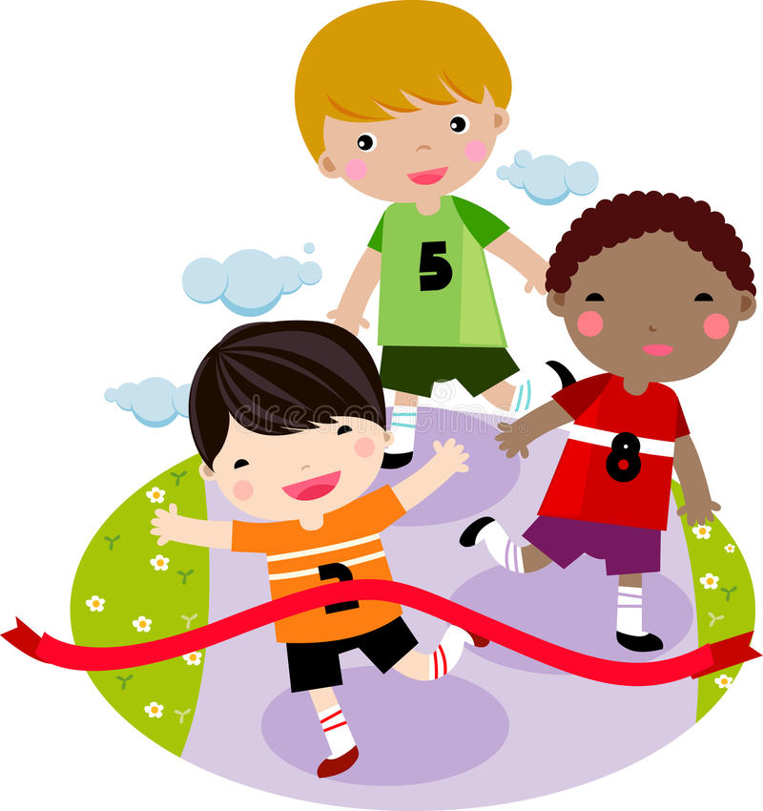

History

Children will:

* Create timelines
* Learn about the Royal Family and how monarchy works
* Learn key terminology (monarch, reign, power)
* Use a range of sources to learn about the past like a historian!
* Make comparisons between life in the past and now

So that they…

Develop an awareness of the past and use appropriate vocabulary for talking about the passing of time

Learn about changes within living memory

Know about the lives of significant individuals, castles

Science

Children will:

* Observe, identify and record signs of

Spring

* Compare winter and spring weather patterns
* Go on a local area walk
* Identify how humans adapt from winter to spring

So that they…

Understand the seasonal changes from winter to spring

Observe and describe weather associated with the seasons and how day length varies

PSHE

Children will:

* Talk about ways to stay healthy
* Discuss the importance of making healthy choices
* Sort foods into healthy and unhealthy foods

So that they…

Know what they need to keep their body healthy

Can decide which foods to eat to give their bodies energy

Understand how to use medicine safely

**Healthy**

**Me**

How You Can Help

* Support your child with their weekly homework (accessible on the Harbinger website)
* Encourage good hygiene and hand washing habits.
* Read every day with your child using BugClub or books that are sent home.

Physical Education

Children will:

* Have weekly indoor and outdoor PE lessons
* Explore movement and dance
* Practise controlling a ball with their hands

So that they…

Create a sequence of movements to music

Control a ball and participate in a range of games

Develop greater stamina and fitness

English

Children will:

* Explore the texts “Dinosaurs and all that rubbish” and “Stanley’s stick”
* Write daily for a range of purposes
* Use a Capital letter, finger space and punctuation in every sentence.
* Write a simple sentence using and to combine ideas.
* Use adjectives to describe and add detail
* Take part in Daily Supported Reading
* Have daily phonics/ double phonics or grammar lessons

So that they…

Verbally articulate their ideas clearly and confidently

Write and edit a descriptive setting

Write and edit and publish an information pamphlet

Write and edit a story based on Stanley’s stick

Apply their phonics knowledge when writing and reading

Develop fluency and reading comprehension

Computing

Children will:

* Learn about online safety
* Enter data onto a computer
* Create tally charts and pictograms

So that they…

Create digital content and present data in an easy and accessible format

Use data to find out information

Art

Children will:

* Measure out arms, hands and legs
* Mix secondary colours using paint
* Use photos to create silhouettes

So that they…

Create artwork that celebrate human variation and diversity

Religious Education

Children will:

* Explore a range of religious celebrations
* Compare how celebrations are enjoyed by different faiths

So that they…

Understand how and why we celebrate special and sacred times.

Maths

Children will:

* Count from 20 to 50
* Partition numbers in tens and ones
* Estimate numbers on a number line
* Say what is one more and less than a number
* Mesaure objects in cm and m
* Compare and measure the mass, volume and
* Solve one step problems
* Review learnt year 1 maths through regular revision
* Talk about their maths and explain their answers

So that they...

Count with confidence up to 50

Compare length, height, mass, and capacity

Choose and use appropriate standard and non-standard units to measure length, mass and volume