

**Maths**

Children will learn to:

* I can use a number line to give the number before / after a given number (to 5)
* I can order numerals to 5
* I can compare 2 quantities noticing more or fewer
* I know that there are smaller quantities within different amounts
* I can continue a repeated pattern
* I can use positional language
* I can talk about the properties of 2d shapes and some 3d

**Personal, Social and Emotional Development**

Children will learn to:

* I am starting to resolve conflicts by listening to someone’s point of view and talking with peers independently
* I can express how I feel emotionally in appropriate ways
* I can select and use resources independently (or ask for help when needed)
* I am growing in independence; I can give things a try before asking for help
* I understand that people have a variety of emotions
* I am showing more confidence with new people

**Communication and Language**

Children will learn to:

* I can listen to others in small groups and 1:1 when the conversation interests me
* I can listen and attend to whole class sessions
* I can retell key events from familiar stories
* I can speak in longer sentences (4 to 6 words)
* I use language to problem solve and organise my thoughts

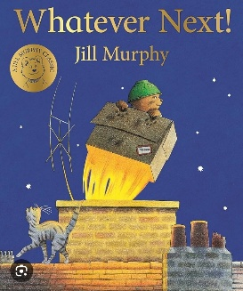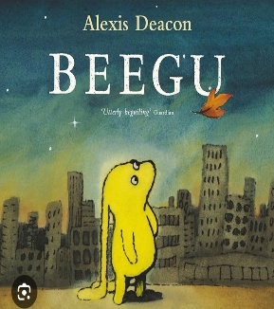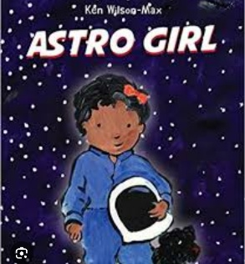

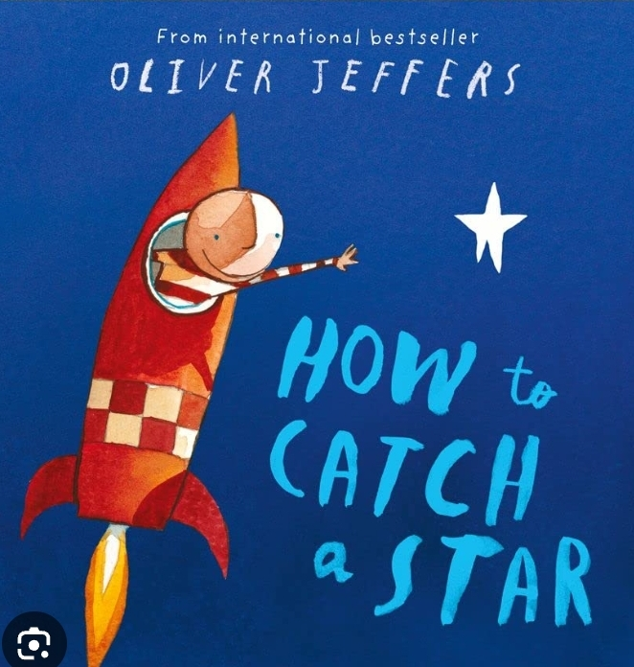

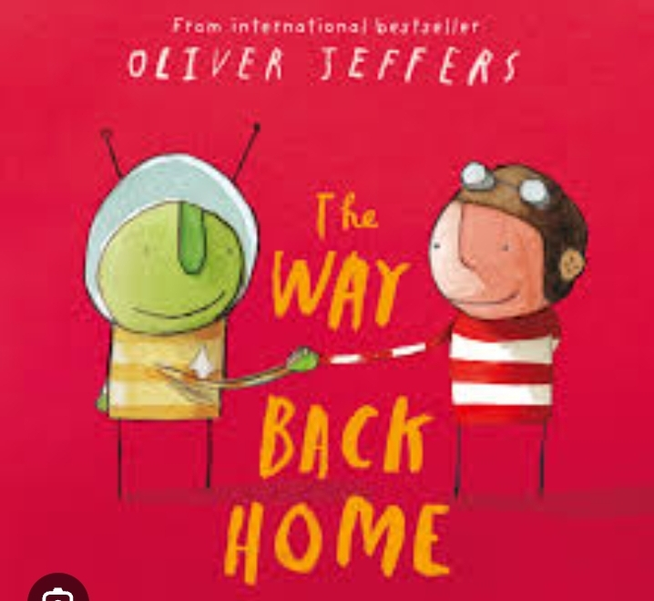

**Expressive Arts and Design**

Children will learn to:

* I am beginning to talk about choices I make in my creative work
* I am becoming more independent in my choice when creating
* I am drawing or painting with increasing detail
* I can respond to music through movement and expressing my feelings and thoughts in response to what I hear
* I am developing more complex stories in my role play / small world play

**Teams** 

Please read and contribute to our **Moonstone Class Teams channel**. Your login details are in the reading diary.

* We share information and learning on our Teams channel, please keep logged in to see what is happening in nursery.

**Physical Development**

Children will learn to:

* I am developing my proprioception (awareness of my body position and movement)
* I can throw and catch a large ball
* I can form some of the letters of my name
* I use a tripod grip when using pens and pencils
* I can use scissors to cut straight lines and I am beginning to cut curves and use other techniques to create things artistically

**Literacy**

Children will learn to:

* I can predict, recall and talk about characters and settings in familiar stories
* I know that some books can be use be obtain information (non-fiction)
* I am beginning to use vocabulary that I have learned from books
* I can form some familiar letters correctly
* I can recognisably write my own name

**Jigsaw – Changing Me**

* I will understand that everyone is unique and special
* I will express how I feel when changes happen
* I will understand and respect the changes that I see in myself
* I will understand and respect the changes that I see in others
* I will know how to ask for help if I am worries about change
* I will look forward to change

Out of this world

Moonstone Class Summer2.2024

**Book Bags and Reading**

Children need to be read to EVERY DAY. We change books on Tues and Thurs. You may change books more often using the blue box outside class.

* Turn the pages, talk about book features such as page numbers, blurb, author, recognise non-fiction
* Use the picture clues – talk about what could happen next
* Talk about the story – retell simple stories in sequence

**Understanding of the World**

Children will learn to:

* I am beginning to make sense of my own life story and my family history
* I am beginning to comment and ask questions about my world and the people around me
* I know some signs of summer
* I explore using all my senses and use a widening range of vocabulary to talk about my observations