Teacher: Tom Jade Class Year: 3 Term: 3.1 2024

English

Children will:

* Explore the historical narrative Escape from Pompei & The Pied Piper from Hamlen
* Use drama and their inference skills to empathise with the characters
* Explore the structural and language features of news-paper reports
* Plan and write their own newspaper reports about events during the Roman era.
* Develop descriptive story telling language
* Read non-fiction texts about the Ancient Romans
* Edit and improve their writing, both with support from a partner and independently

So that they…

* Understand the structure and language features of different fiction and non-fiction genres
* Are aware of the audience and purpose of the genre they are writing in.
* Can write newspaper reports
* Write a narrative based on a

traditional tale

* using features learnt which  
  are engaging and interesting
* to read.
* Know how to edit and  
  improve their writing

Maths

Children will:

* Continue to solve problems using their knowledge of fractions
* Learn about decimals which are equivalent to one half, one quarter and one tenth
* Revise written and mental strategies for addition, subtraction, multiplication, and division
* Solve word problems which have more than one step, using all four operations

So that they…

* Can calculate fractions confidently
* Recognise and use decimals
* Can solve calculations quickly and  
  confidently
* Know how to solve problems

History

Children will:

* Use their history lessons and reading lessons to find out about life in Ancient Rome
* Learn how the Roman Empire spread
* Find out how and why the Romans invaded England and the impact they had on the country
* Discuss what made the Roman Empire so powerful and successful

So that they…

* Develop an appreciation for   
  how the Romans changed life in   
  Britain
* Can carry out discussions about  
  their learning, using historical   
  evidence to support their ideas

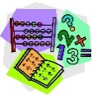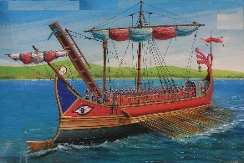



Science

Children will:

* Investigate how sounds are made and how

they travel through a medium to the ear

* Use instruments to find patterns between the pitch and volume of a sound and how to produce them
* Explore sounds getting fainter as the distance from the sound source increases
* Carry out a practical enquiry; recognise a fair test, make accurate measurements and draw conclusions

So that they...

* Know and understand how sound and vibrations operate in the world around them
* Can consider reasons needed to reduce and not reduce sounds
* Explain their findings using scientific language and writing

**Remarkable Romans!**

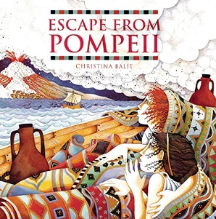

Art

Children will:

* Explore the work of international artists who use found and recycled materials
* Use recycled materials to create expressive and playful sculptures
* Work with pattern and colour
* Practice joining techniques to create sturdy pieces

So that they...

* Become familiar with Roman architectural style and recognise some famous Roman buildings
* Understand how to select and use a wide range of tools and equipment to perform practical tasks
* Develop their paper engineering skills

How You Can Help at Home

**Times Table Rockstars**: Please make sure children are practising their times tables regularly at home.

**Reading:** Please continue to read with your child at least **three times a week**. Children can borrow books from the classroom, the school library or plan a re-visit to the Idea Store! Reading diaries should be completed on our online padlet at https://padlet.com/jadeclass1/read and homework should be brought in on **Fridays**.

**Homework** will be set every half term. Some homework will involve logging into Purplemash.

**PE:** PE takes place on **Wednesdays and Thursdays** Children will need to come to school on these days wearing suitable PE clothing.

Computing

Children will:

* Learn how to code and program algorithms

So that they...

* Instruct a robot to perform a task